EDU 543 VAPA Lesson Plan

Fairy Tale/ Visual Arts
Grade Level: 2nd
Candidate Name: Ashley Gorecki
Locate a VAPA lesson plan on WWW and work backwards to fill out this lesson plan form. Fill out the student information form at the end of this lesson plan to help you know your individual students. Download TPA 1 and 2 and use as a reference as you complete this lesson plan. This plan is intended to provide you with some of the major skills and types of writing needed for completing TPA 1 and 2.
Learning about your students: At the bottom of the lesson is a custom student interest survey that should be given out prior to the assignment. This will allow the teacher to narrow down book ideas, and group students together based on their interests. Three broad areas of student characteristics we need to be aware of:
– Abilities (through identification and programming)
– Interests (personal, occupational, hobbies, etc.)
– Learning Styles (how a student is allowed to pursue a topic)
Describe the students in this class: Use your fieldwork school for information. (view their web site and find supporting information)  Include the following:  The students I observed during a visual and performing arts lesson are in a 2nd grade class. They range in age from 7 to 8 years old. The class has slightly more boys than girls. There are 12 boys and 3 girls in the class. This particular class is a special education class however all of the students are diploma bound and follow the districts curriculum. These students are classified as emotionally disturbed and suffer from a variety of emotional disturbances. With that being said, a majority of the students come from a low socioeconomic level, including group homes. Eighty percent of the class qualifies for free or reduced lunch. The students are not very enthusiastic about school or life in general. Although the attendance rate is very high, many days the students are mentally checked out and refuse to do school work. In Mrs. Murphy’s class, there is a heavy emphasis on learning appropriate behaviors and focusing on reaching each students goal so that they can mainstream into a general education class. Each student has their own personal education goal, and majority of these goals are centered around English Language Arts. Visual arts instruction is incorporated as a free time option as well as ELA supplement that is incorporated with the grades standards. Mrs. Murphy attempts to incorporate as much visual arts into her lessons as she can, however due to pressing goals having to be met, creative anticipatory is often put off.  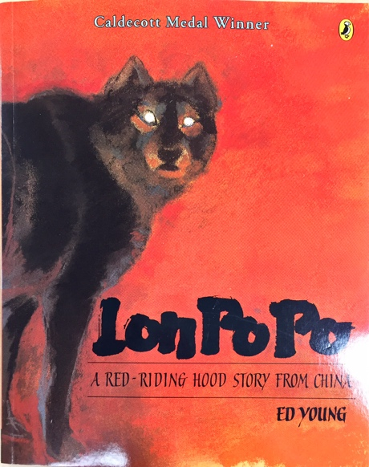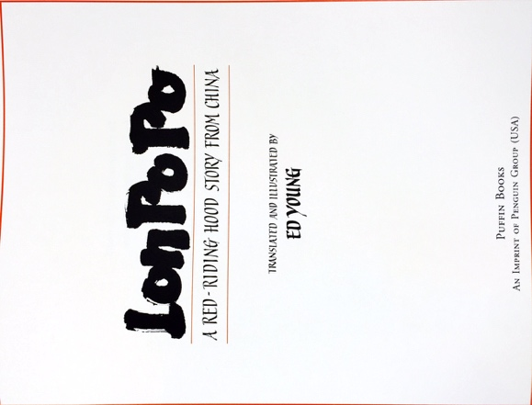 | List potential high risk (type of) students, issues, or anticipated difficulties with engaging students in this learning opportunity.  This particular special education class is labeled emotionally disturbed, all of the students are potentially high risked students. They all have a variety of disturbances ranging from ADD, ADHD, to anxiety, and depression.  Some students lack fine and gross motor skills causing it to be difficult for them to draw, write and color.  Students may not have the confidence to try to express themselves through visual arts. They also may not have interest in art, causing them to not give as much effort into the project.  Students may also lack in confidence causing them to reframe distant when interacting with peers and staff.
State Adopted Content Standard(s)  List full Standard with grade level and standard number.  Visual Arts 1.0 – Artistic Perception  Students perceive and respond to works of art, objects in nature, events, and the environment. They also use the vocabulary of the visual arts to express their observations.  1.1 Perceive and describe repetition and balance in nature, in the environment, and in works of art.  Visual Arts 2.0 - CONNECTIONS, RELATIONSHIPS, APPLICATIONS Students apply artistic processes and skills, using a variety of media to communicate meaning and intent in original works of art.  2.1 Demonstrate the beginning skill in the use of basic tools and art-making processes, such as printing, crayon rubbings, collage, and stencils.  ELA Standards  2.RL.2.6 Acknowledge differences in the points of view of characters, including by speaking in a different voice for each character when reading dialogue aloud.  2.RL.2.2 Recount stories, including fables and folktales from diverse cultures, and determine their central message, lesson, or moral.  2.RL.2.7 Use information gained from the illustrations and words in a print or digital text to demonstrate understanding of its characters, setting, or plot.  2.RL.2.9 Compare and contrast two or more versions of the same story (e.g., Cinderella stories) by different authors or from different cultures. | Language Arts: This reinforces the understanding of text structure. Students gain a deeper understanding of different point of views, characters, setting, or plot. This unit would be consistent with the ELA standards listed to the left.
Academic learning goals (objectives)  - Students will identify and explain the points of view of characters.  - Students will recount stories, from different genres, including many from different cultures.  - Students will use information given to demonstrate an understanding of characters, settings, or plots.  (How will they demonstrate these objectives?)  WORDS TO KNOW  asymmetry—v. Intentionally unbalanced parts on opposite sides of a perceived boundary giving the appearance of equal visual weight.  background—v. The part of the picture plane that seems to be farthest from the viewer.  content—v. The messages, ideas, or emotions expressed in a work of art.  contrast—v. The difference between two or more elements (e.g., value, color, texture) in a composition; juxtaposition of dissimilar elements in a work of art; also the degree of difference between the lightest and darkest parts of a picture.  design—v. The plan, conception, or organization of a work of art; the arrangement of independent parts (the elements of art) to form a coordinated whole.  elements of art—v. Sensory components used to create works of art: line, color, shape or form, texture, value, and space. | What specifically will students be able to know or do?  Students should be able to identify important characters and understand different point of views. They should also be able to recount stories, including those from different cultures.  In addition, the students should be able to use information given about the character in order to create a closely related depiction of the setting, character or plot. Within the painting of butterflies, the students were able to recall specific details about the butterfly in order to create a realistic depiction of the insect. One example is the symmetry in the butterfly’s wings. The students were able to recall this fact and demonstrate the understanding of the semantical concept.
Materials, Technology, other Resources  Materials  - White paper  - Old magazines  - Glue  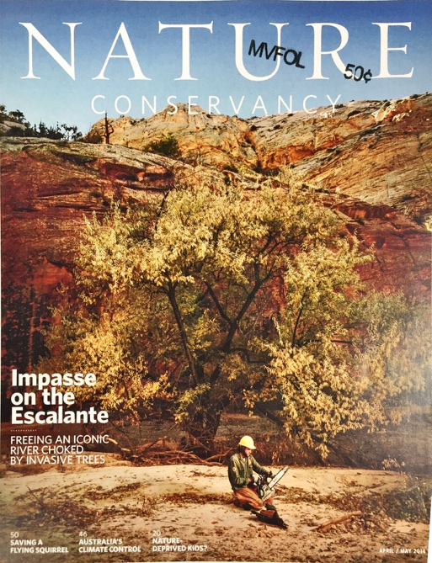  Resources  - Collage-art projects for kids  http://artprojectsforkids.org/category/view-by-media/collage/  - Teaching difference and similarities through fairytales  http://tip.drupalgardens.com/sites/g/files/g764316/f/201307/Freeman_unit_0.pdf  - Chinese art examples for students to view  http://www.ducksters.com/history/china/chinese_art.php | Rationale: Why did you select these materials?  The lesson is part of a larger overall language arts unit. By introducing visual art project, the students are able to engage in the information previously taught in a different way. The materials and resources were chosen as a continuation of the learning process. These materials will assist students in creating a collage of a particular fairytale story.
Assessment: What evidence of learning will you collect during this lesson that will indicate the extent the students have completed the lesson goals?  Feedback for Teacher  - Student complete the collage by using appropriate photos  - Student response to inquiry  - Student is able illustrate the difference between diverse cultures by discussing the similarities and difference between peers and myself.  Feedback for Student  Teacher response  - Point out the great work and effort that each student put into their projects. Give compliments before providing giving constructive criticism. Students will also be given an element of Art Rubric where they can see what is expected of them and help them understand how their project will be graded.  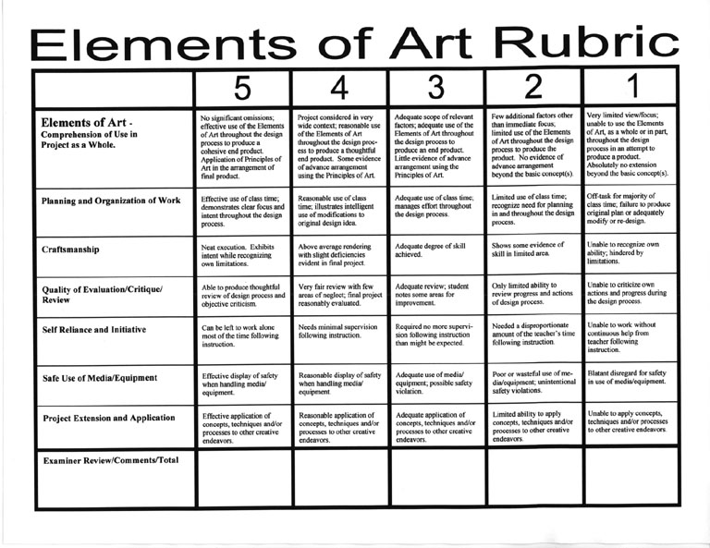 | Why did you select this evidence of learning and how will it show student competence?  The student is able to pick the proper images that will allow me to gauge understanding as the students will have to analyze and synthesis certain plot and story elements. The student will pay particular attention to the size of the clippings, the colors and the relevance. As this lesson play uses inquiry instructional strategy, I picked assessments that would demonstrate the student’s ability to create work product using higher order thinking skills.  I also plan to walk around the room, asking students questions about their project and story. While doing this I will keep a chart that allows me to keep track of whether or not the student is understanding the concept.
Instructional Strategies: What content specific instructional strategies are you using to teach this lesson?  This lesson is taught based on the guided exploration instructional strategy. This teaching strategy allows me as the teacher to models a concept or skill that is part of a larger set of skills or knowledge, and guides the students as they practice this first step. The process is repeated until the students master the expected knowledge and skills of the lesson. This strategy is particularly useful for introducing new skills that are developed sequentially. Moreover, I will also be allowing the students to explore their own creativeness as soon as they are decided on their fairy tale of choice and have an understanding about what is expected. At the end of this project the student will have time to use a think-pair share strategies and share their visual arts ELA project with the class. This will allow them to explain their art as well as the story they based the project on. | Rationale: Why did you select these strategies?  I selected the guided exploration instructional strategy because I knew that the students would need in depth instructions about how to create a college. With that being said, I also wanted the students to take it upon themselves to explore different art components so that this project is unique to each student.
Student Learning Activities:  List Activities and describe each of the teaching steps in the order that you will implement each step.  Activity One:  WARM UP  Teacher Note: Set deadlines for project completion. Let students know in advance when this project would be finished. Student can take home the project if needed. You decide what is appropriate for your students.  - Pre-arrange groups so that students that need additional help are seated next to students that can help.  - Review vocabulary and terms.  - Provide multiple examples of the project.  - Explain to students that they have to use terms and past knowledge in order to be successful in completing this project.  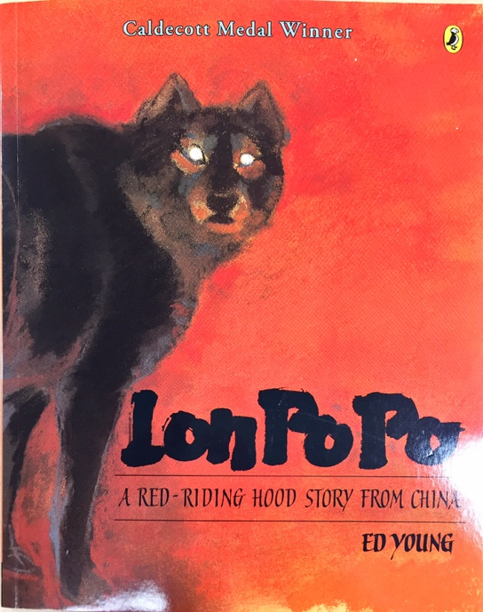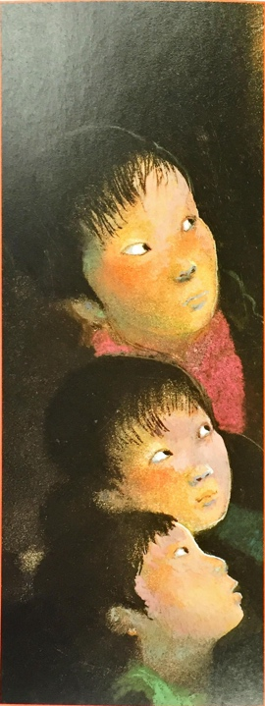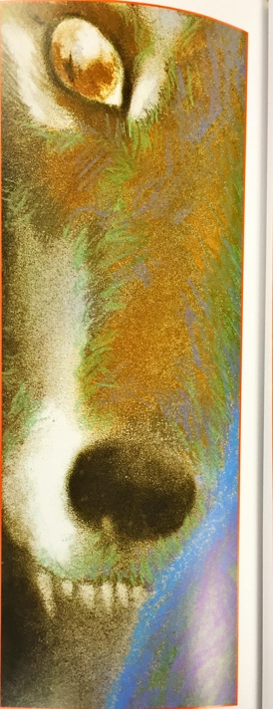  Activity Two:  MODELING (Presentation of new material, demonstration of the process, direct instruction)  - Note: This section should only take one day to complete.  - Student will pick one fairy tale story to base their visual art project on.  - Students will receive a blank white paper and pencil and asked to sketch out their main characters and the background elements that will add to the story line.  - Students will need to reference their fairy tale story so that they have a guideline for the rough draft.  - Ask students to:  - “Identify the characters and their relationship (who is the hero, villain, gossip, etc.)  - “Identify the setting so that you can properly describe the background and gain an idea of how you want to design the background of your collage.  - Read the story aloud in its entirety.  - Choice one or two pages that best characterize the entire story.  - Pause to check for understanding and discussion at the end of giving direction.  - “What is happening in the story?  - “What kinds of emotions and actions are taking place in this scene?”  - “What kinds of settings are appropriate for the story?”  - “Do you have any questions?”  - “What will your audience guess is going to happen after this scene?”  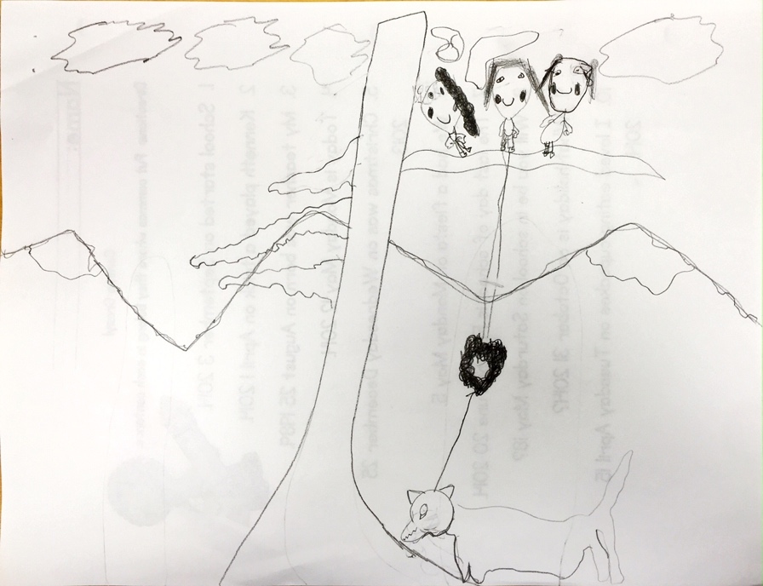  Activity Three:  Execution: (Give the students all of the materials they need in order to begin and complete their final project)  - Note: stress how important it is to take their time and think about what they want their final project to look like.  - After beginning the final project the student will not be able to change their fairy tell story.  - Provide the students with ample magazines that will allows them to pick, cut and paste onto their final cardstock paper.  - Explain the idea of layering the background and foreground giving an over-all vision of the complete setting.  Activity FourDemonstrate the importance of getting up in front of peers and speaking)  - Share their art work and fairy tale story with the class.  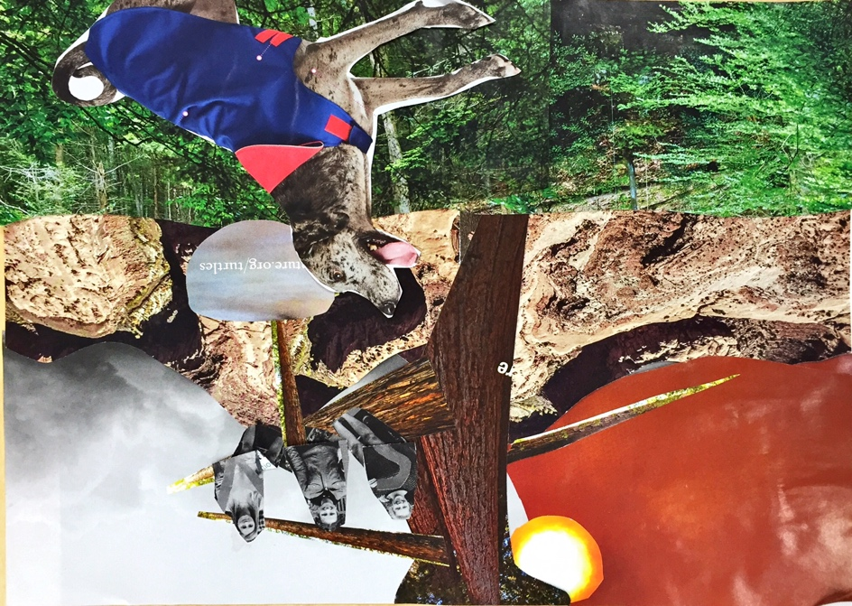 | Rationale: Why did you select these activities?  I decided to do a Modeling stage so that the students can be sure that they picked the right fairy tale story and that they are aware of all of the elements they need to include so that their project fully depicts their story. In addition, it gives me the opportunity to review important concepts that the students might not necessary understand. This is a great pre teaching moment as well as an opportunity to see where the students are after giving general instruction. Art vocabulary terms as well as plot concepts can also be reviewed so that the student has a greater understanding of the different elements of a story. Again this gives me the ability to progress monitor understanding through observations.  How will they help students accomplish the lesson goal and standard?  Each activity helps students accomplish the lesson goals and standards. In step one, Students have to listen to the instruction, and recall what they previously learned and use that to complete the project. Activity two and three allows the students to demonstrate the beginning skill in the use of basic tools and art-making processes, such as printing, crayon rubbings, collage, and stencils.
Student Work: Make the assignment/activity (use as a model).  GUIDED PRACTICE (Application of knowledge, problem solving, corrective feedback)  - Give precise instruction to the class, allowing time for questions and group thought.  - Have each student pick their fairytale story and point out who the main characters are, and what the plot and setting is.  DEBRIEF AND EVALUATE (Identify problems encountered, ask and answer questions, discuss solutions and learning that took place. Did students meet expected outcomes?)  - After the student has picked their fairy tale book and point out the important aspects of the story the student is ready to start on the activity two, modeling.  - Ask students:  - “Which main characters are important to the story and will be included in the art piece?”  - “What colors and patterns are native to this culture?  - “What is the setting, how will you depict the setting in the background or foreground?”  - “What have you learned about culture that this story and art derives from?”  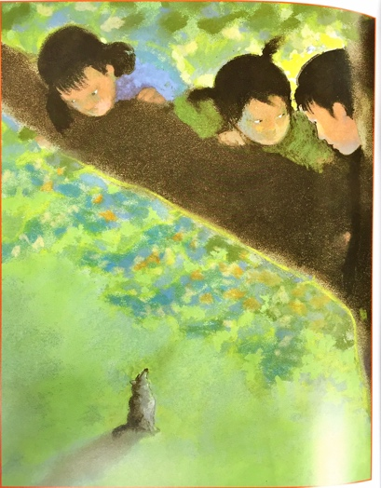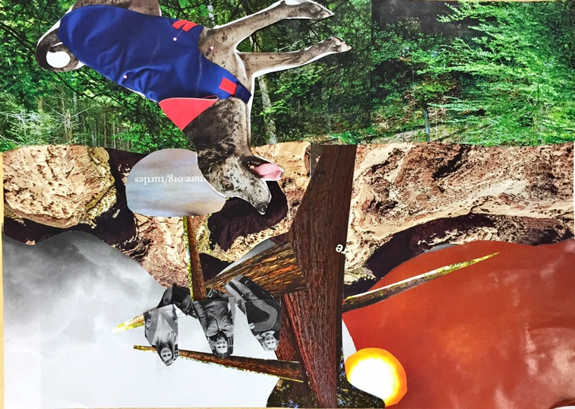  EXTENSION (Expectations created by the teacher that encourages students to participate in further research, make connections and apply understanding and skills previously learned to personal experiences.)  - Highlight the directions and give an example of how the final project is expected to look.  - Allow the students to complete the project and add components that makes the art work their own.  - Work with a friend or family member more about art, cultures and fairy tales that are similar. | Explain how you will use this work sample.  The guided practice and debrief and evaluate portion of the lesson will help me to check for understanding. Reviewing any part of the art instruction as well as new art vocabulary. In addition, the work extension exercise will allow students to compare different fairytales as well as where the stories came from and fairy tales that they can be compared to.
Student Grouping  How will students be grouped during this lesson? Keep in mind that the groupings may change during the lesson (ex. begin with whole group and then divide into small groups).  The beginning of the lesson will be done in a whole group During the whole group instruction, I will review what is expected while working with their peers. Particular expectations will be addressed such as treating each other with respect, walking in the room and using a low voice level. As the project begins the students will be free to work around their peers, the ones to their right and left. Seating has been assigned so that students are paired with excelled and struggling students. Each student’s strength will be used and is necessary for completion of this visual art project in its entirety. | Rationale: Why did you select this type of grouping (ex. whole group, small groups, boys, girls, ELA/ELD)?  I decided to allow the students to work with class mates they are close to because of the previously assigned seats. The students are arranged so that the students next to them are at a different academic level. This will allow the students who perform low have a high performer next to them that can help when I am not available.
Progress Monitoring of Student Learning:  Evidence of mastery for each standard will be determined by their final project product which will demonstrate their academic understanding of identifying the following:  - Students will identify and explain the points of view of characters.  - Students will recount stories, from different genres, including many from different cultures.  - Students will use information given to demonstrate an understanding of characters, settings, or plots.  Checking for understanding will be done through the lesson by asking the questions mentioned in debrief and evaluate portion of the lesson plan. In addition, students will be required to demonstrate their knowledge by creating a story scene with clip art and pictures from magazines. This will allow the teacher to check understanding. Moreover, the teacher will further progress monitor student learning through informal observations of student art work and final presentation to the class. During the entirety of the project the teacher should walk around the classroom taking note of what students are struggling and excelling in. This can be done on a simple graph and the use of negative and positive signs next to the students names.  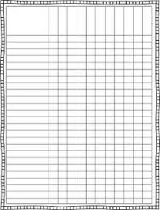 | How will you monitor how the students are doing with learning this lesson?  I will observe the student’s projects process by walking around the class asking questions, giving advice and aiding the student in any way they need. Through observation in whole group and small group discussion.
Difficulties: List and explain the 2-3 difficulties or problems you anticipate that all students might have with this content and these learning activities.  1. Students may have problems understanding the main characters, plot and settings.  2. Students may experience problems drawing, cutting and using fine motor skills.  Explain how you will solve these problems so all students will learn to full potential.  I will reteach the main ELA standards pertaining to the differences in the points of view of characters, how to recount stories, focusing on fables and folktales from different cultures, and determine their central message, lesson, or moral. Moreover, I will also review how the students should use information gained from the illustrations and words in a print or digital text to demonstrate understanding of its characters, setting, or plot.  I will model different ways to draw, cut and create a college. Using teacher tube videos about sketching and creating art pieces I will allow the student to learn different techniques that I am not personally teaching. | Why do you think these might be potential problems?  Based on this classes population I can predict some of the potential problems. I know that some students struggle with reading comprehension, so while creating this lesson I can assume that those students will need more assistance in retelling the story and differentiating the characters, plot, point of view and setting.  Moreover, I am aware that some of the students are delayed with their fine motor skills and comprehension of new terms.
Adaptations: List steps that you could take to ensure learning for specific students experiencing these difficulties in the spaces below.
ELD Learner:  Strengths- Student is a visual learner, so he will be very good at expressing his knowledge of the subject through creative art. Moreover, he will also be great at helping students throughout the project.  Weaknesses – The student needs additional practice in communicating his needs and interests with staff and other students.  Your intervention or adaptation: I would like a non ELD student to communicate different ideas and stories to this student so that he is able to hear more information about the diverse fairy tales learned for these projects. I will work with the student and help him complete any writing aspects of this project. Moreover, prior to teaching the lesson, I will pull a group of students that I suspect will have difficulties with this project and do a pre-teaching activity. Here I will introduce new vocabulary and concepts that they might not be familiar with. By doing this the ELD learner will feel more comfortable entering into a new task. | Rationale:  It is extremely important that EL students are given ample opportunities to ask questions and feel comfortable to ask for information to be repeated or further explained. This lesson will allow the student to practice this skill. Working with the student, we will allow the student to ask many questions and work alongside another student that will also be able to help. I will re-teach vocabulary words to assist the student with understanding the concepts of different fairy tales.
Special Needs Learner:  Strengths: The student is an auditory learning, and is very advanced in reading and typing.  Weaknesses – This student needs additional practice cutting, gluing and drawing. This lesson plan will give the student the opportunity to practice the skills of fine motor skills in their IEP. The IEP goal is as followed; By June 2nd 2016, when given a craft activity involving cutting with scissors, --------- ------- will cut on a line at least (5) inches long with not more than (1) inch length more than (1/4) inch from the line for (4 out of 5) craft projects. The student has already reached this goal, so allowing him to cut objects that are smaller out is a huge accomplishment.  Your intervention or adaptation: I will ask the student to practice both at school and at home in order to be prepared enough to cope with the skill and the stress and anxiety this skill with cause. Moreover, I will work close to the student so that I can help the student and gage his struggles and progress. | Rationale:  Since this student has fine motor delays, more time will have needed to be devoted to cutting and gluing the images to the paper. Prior to this activity the student should have an opportunity to practice cutting on a straight and curved line. This will help prepare the student for the upcoming assignment.
Student with Behavior Issues:  Strengths – This student has a strong artistic eye and enjoys drawing, painting and sculpting. This student also enjoys working with different technology to create art projects.  Weaknesses – This student has ADHD and is easy to anger. He often has trouble collaborating with other students, however his love for art trumps his anger towards others, so he is able to complete the assignment fairly easy.  Your intervention or adaptation: I will advise the student to take his time on the project and lay out options for him to do when he is completed. These options will be very straight forward and detailed. This will help eliminate any confusion that could lead to an unfavorable behavior. Throughout the assignment I will also remind them that he is able to take breaks periodically so that he can remain calm and focused. | Rationale:  Since this student has a strong artistic eye, I want the student to take control of his project. When completed the student will be able to do a second project associated with ELA art or he can work on story teller on the computer to keep busy while the other students complete their work.
Reflection: What have you learned about planning instruction for a diverse student population in this content area?
It is important to understand your student’s strengths and weakness in all areas. This lesson focuses on ELA and reading comprehension, however it adds a visual arts project that allows the students to express their knowledge of the subject.

What area of this instructional plan was easy to complete?
Once the ELA goals were determined and aligned to the standards, is became easier to create an art projected that reflected the students understanding of the material. Applying this visual art project to the ELA curriculum gave me a window to introduce art terms and concepts while pertaining to the ELA standards. Moreover, once I had the instructional strategies written, the difficulties with teaching the lesson became evident. Based on my knowledge of the diverse students, I was able to make the appropriate changes and adaptations to the instruction and differentiate instruction where necessary.

What area will you need more knowledge/skill in order to do the task well?
Giving students the opportunity to review different fairy tales and pick their favorite allows the students to gain control over their project. I also need to learn the proper art terms so that the students are able to recognize and use these terms in the future. I will also need to manage my time properly so that this project does not exceed the allotted time devoted.

Use form below for finding out about your students prior to planning your lessons/fieldwork

Getting to know your students - Work Backwards: What questions can you ask to get the information in this case study? Turn each statement into a question and provide a source or a person you could ask to get this information.
Rolando is an 8-year-old second-grade English learner. He was born in Southern California to parents who only spoke their native language. His parents are from Mexico and migrated to the U.S ten years ago. Rolando has one younger sister who is not in school yet. While Rolando has been enrolled in the Beaumont Unified School District the past 3 years his native first language is Spanish. The only time he is exposed to English is while at school or out of the house. He is seldom or never absent from school. The CELDT results indicate an overall score in the early intermediate range, and he has been identified as an English learner.

Question 1: How old is Rolando? | Ask the student, teacher or look at the students personal file.
2. What grade is Chan in? | Ask the student or teacher.
3. How well does the student socialize with his peers? | Ask the teacher, or observe the student’s behaviors.
4. Does the student receive speech or any other assistance that would allow him to catch up to his classmates? | Ask the teacher.
5. Does the student sit next to any classmates that are excelled in ELA? | Ask the teacher.
6. Is the student being provided any extra work that he can do at home? | Ask the teacher or parent.
7. Is the student’s family familiar with any additional help that is provided throughout the community? | Ask the teacher
8. What type of extracurricular activity excites the student? | Ask the student.
9. When was the students last IEP? (Since he was also diagnosed with Autism) | Ask the teacher, look at the student cumulative file.
10. Is the student engaging with other students who excel in the English language. | Ask the teacher and observe.
11. Is the student’s sister exposed to English? | Ask the teacher or parent.

12

13

14

15

16

17

